Git clone to download the source code.
PreRequirments
=============
Ram → Free -m
CPU → cast /proc/cpuinfo
Storage → 20GB
Launch the Ec2 Instance with following packages
Install the Java + Jenkins in Ec2 instance (of same Version)
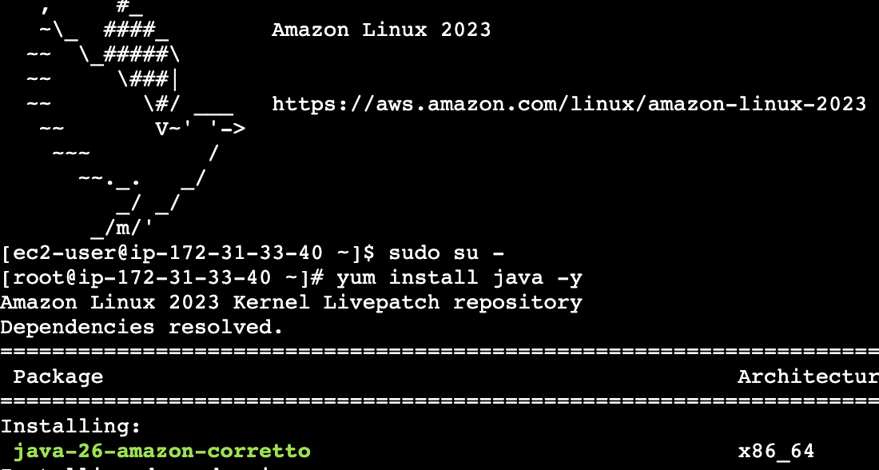
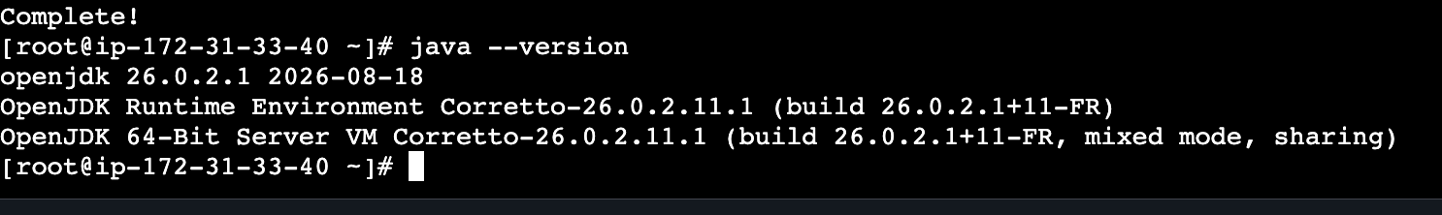
Downloads the official Jenkins YUM repository configuration file and saves it to `/etc/yum.repos.d/`
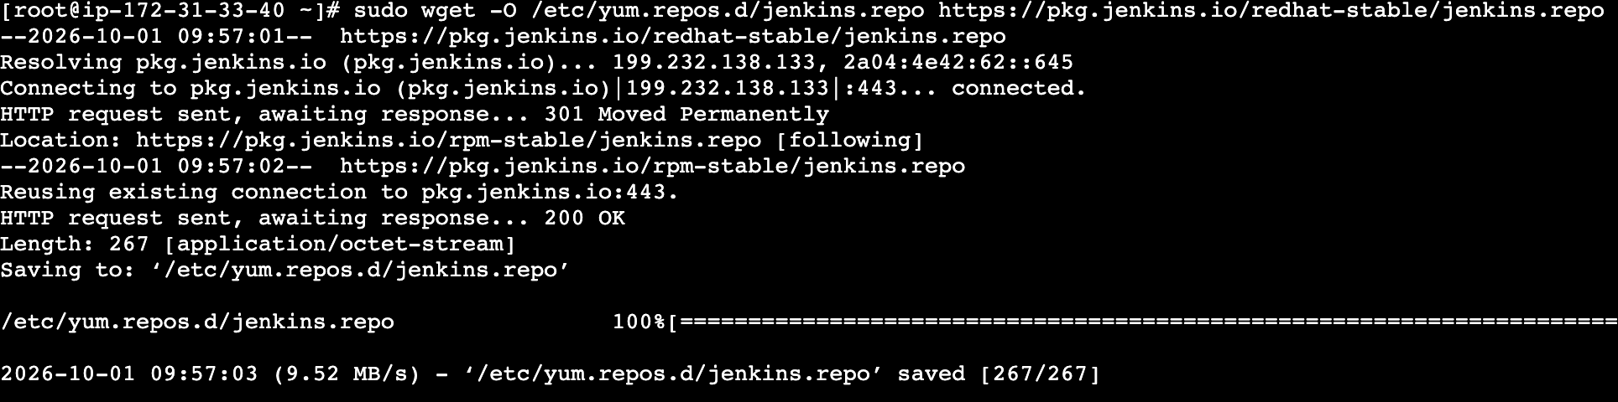
yum upgrade -y
yum install jenkins -y
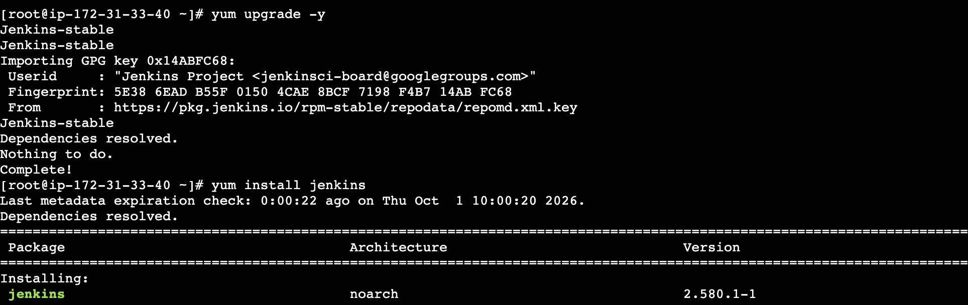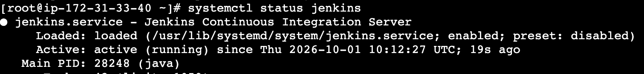
3.26.235.230:8080 → IPV4 of Instance
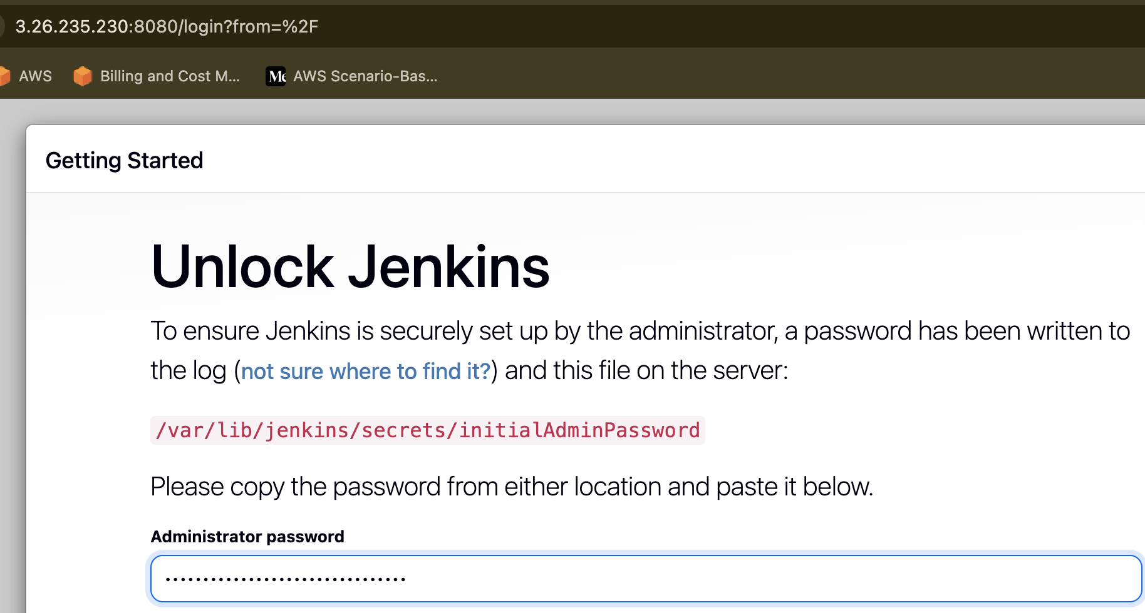
Wait for required plugins to get download
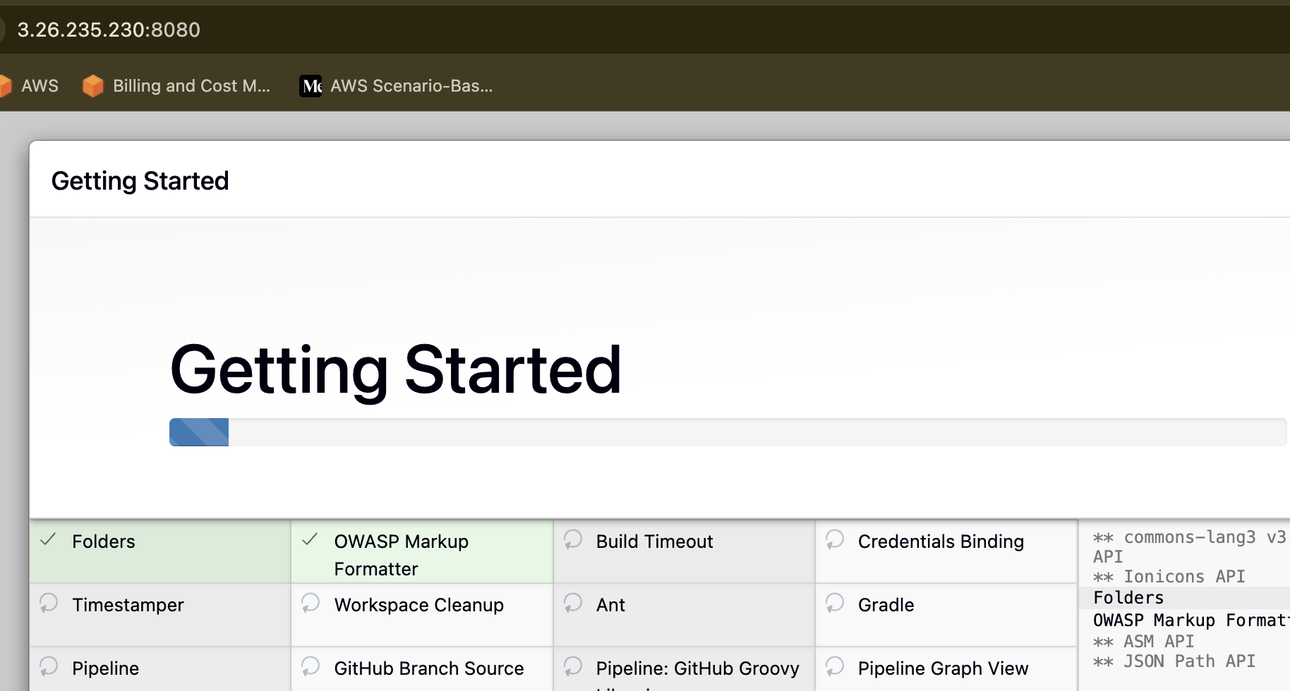
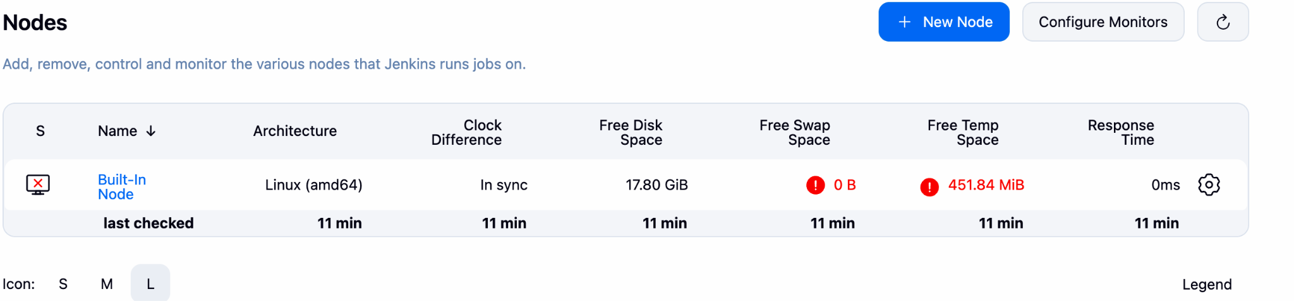
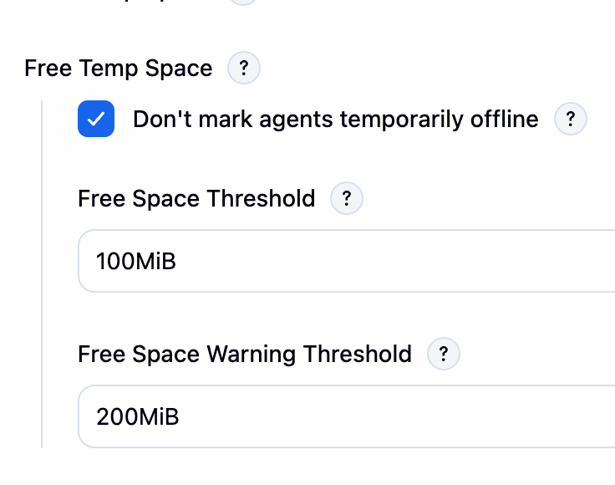
Go to Plugins → Look for sonarqube → Insatll
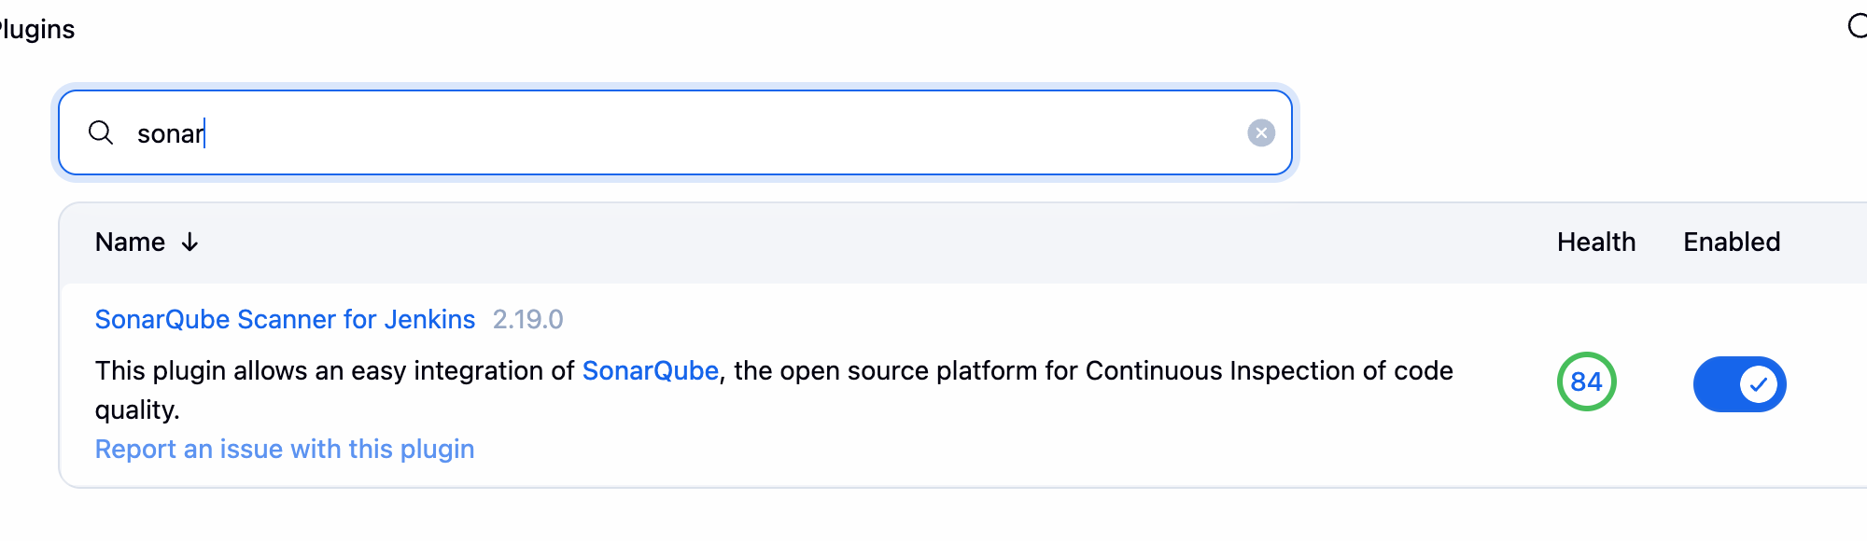

Create the Job to clone the Code and Files
→ If there is error 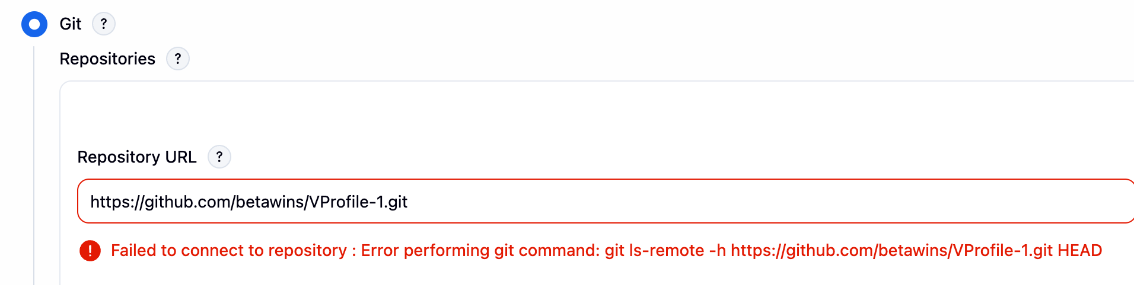
Install git in your Instance
dnf install git -y
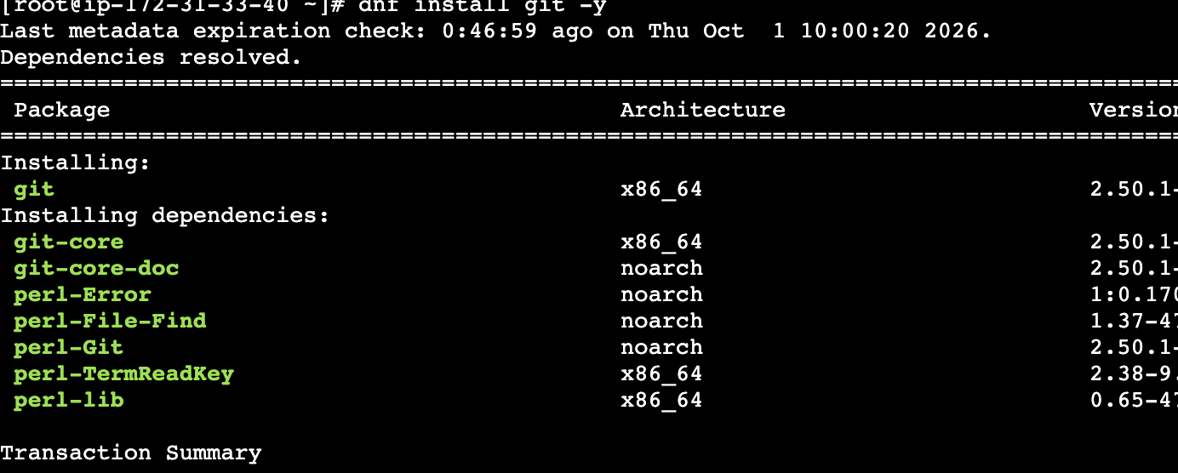
Now the error is resolved.
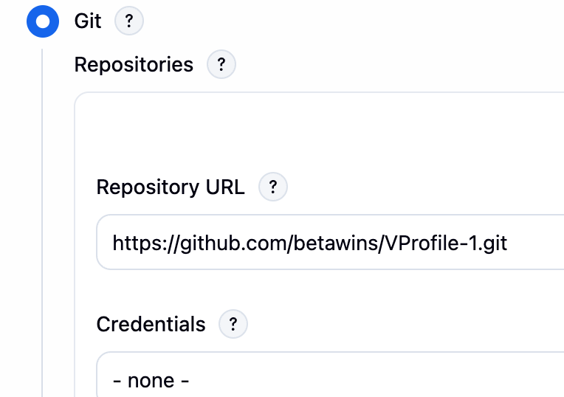
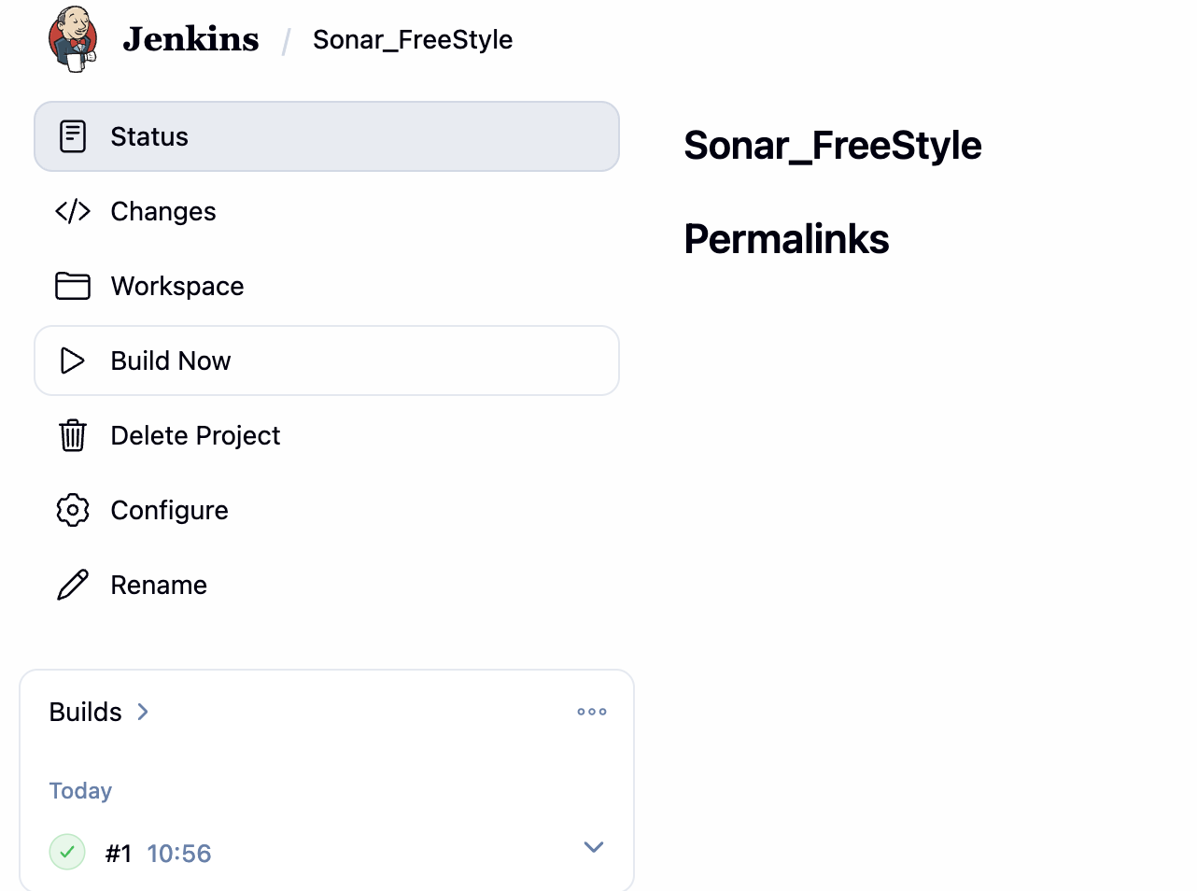
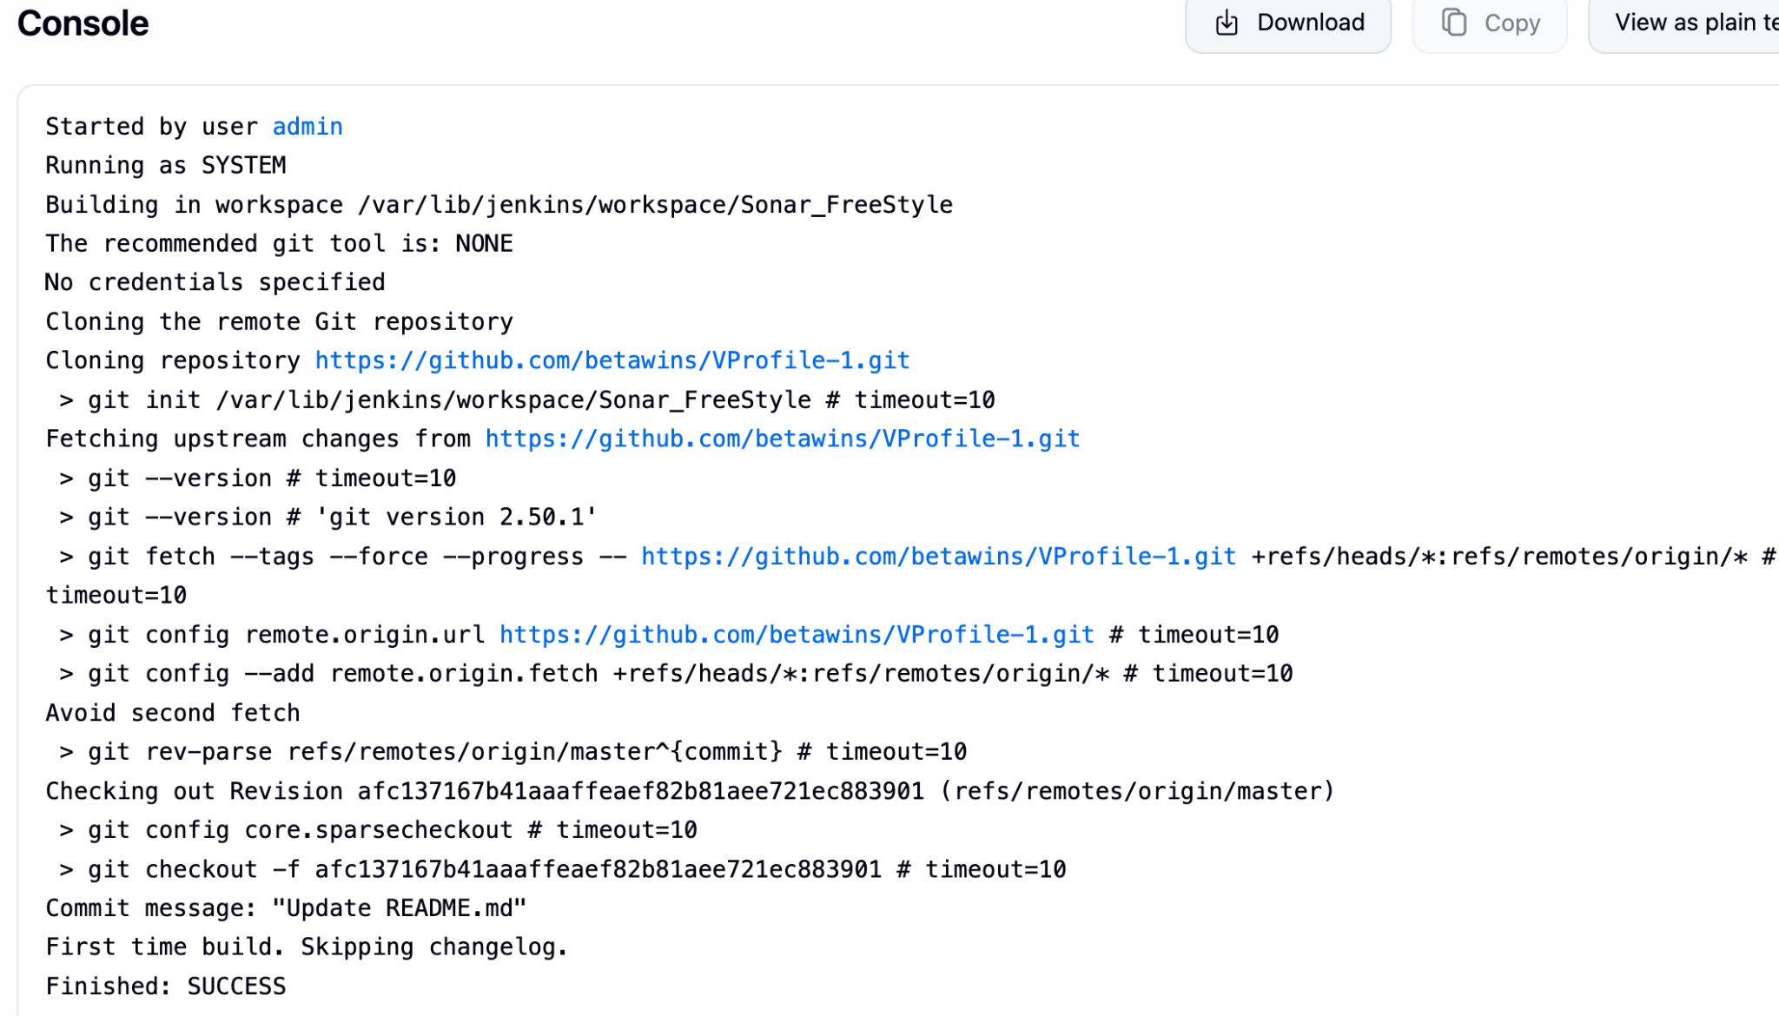
Sonarqube Integration to check the quality of code.
Now install the Postgresql in ine Ec2
dnf install -y postgresql15-server
postgresql-setup --initdb

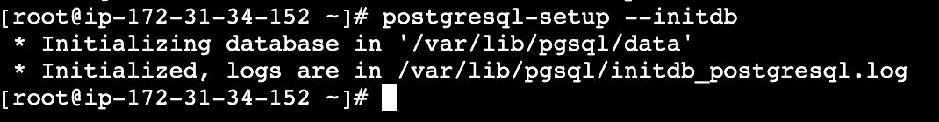

systemctl enable --now postgresql
→ Create the user1 and user2 with password.
→ Make those users Owner.
→ Give all Privileges.
CREATE USER user1 WITH ENCRYPTED PASSWORD 'user1_pwd@098';
CREATE DATABASE user1_db OWNER user1;
GRANT ALL PRIVILEGES ON DATABASE user1_db TO user1;

CREATE USER user2 WITH ENCRYPTED PASSWORD 'user2_pwd@123';
CREATE DATABASE user2_db OWNER user2;
GRANT ALL PRIVILEGES ON DATABASE user2_db TO user2;
Installing java21 for SonarQube.
dnf install -y java-21-amazon-corretto-devel

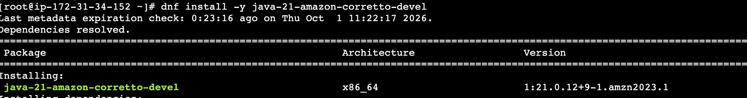

Check the SonarQube is up and running
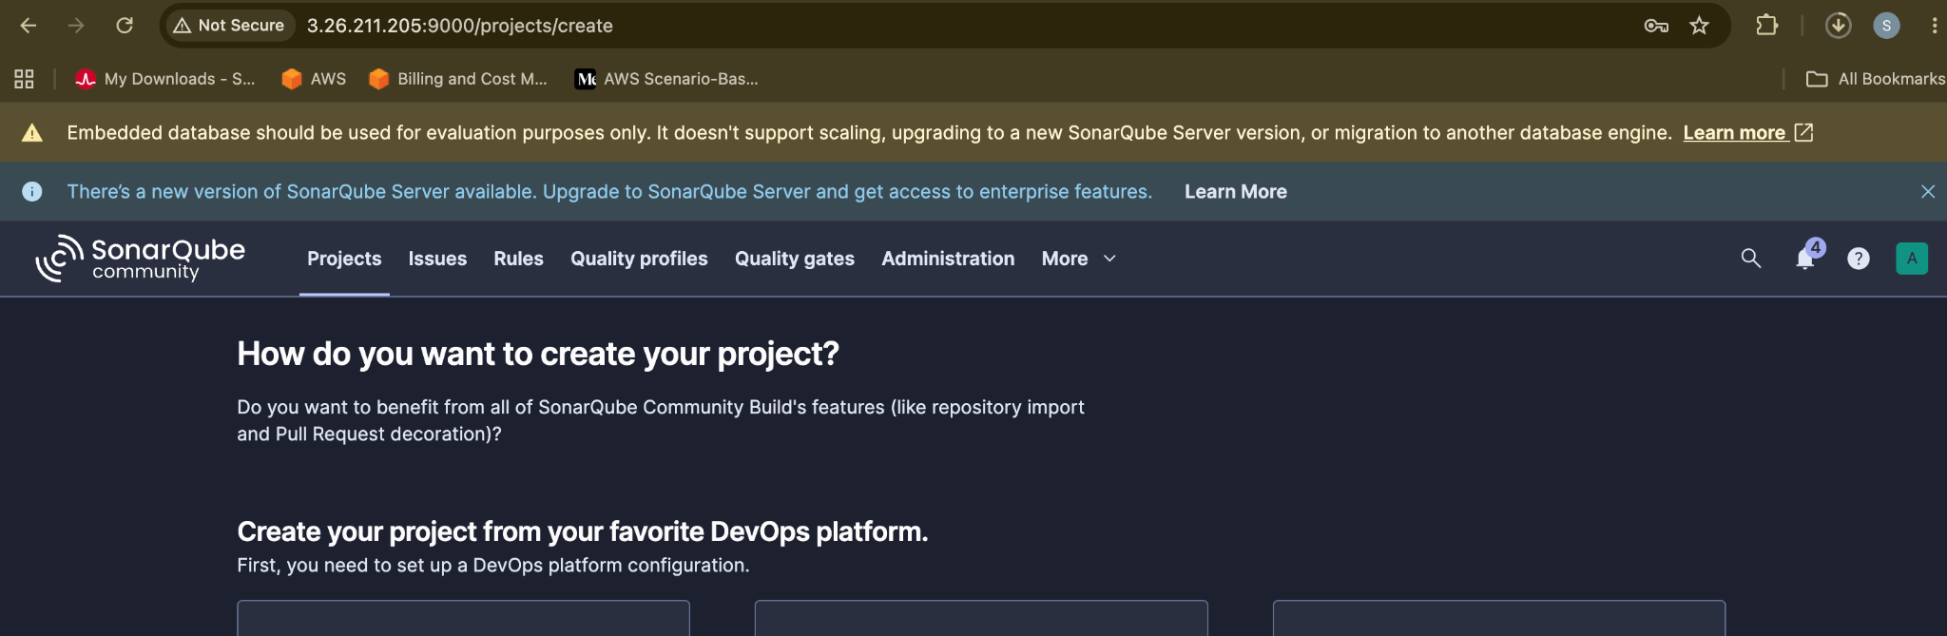

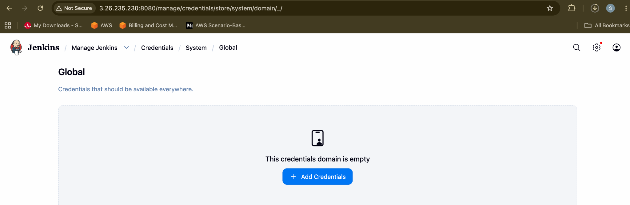

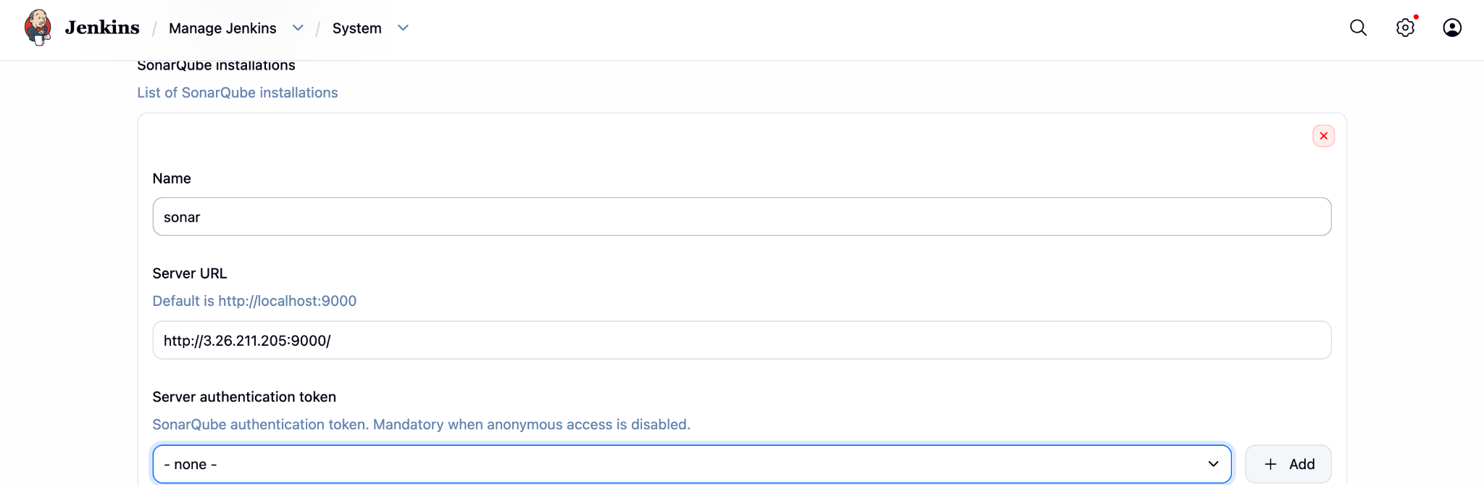

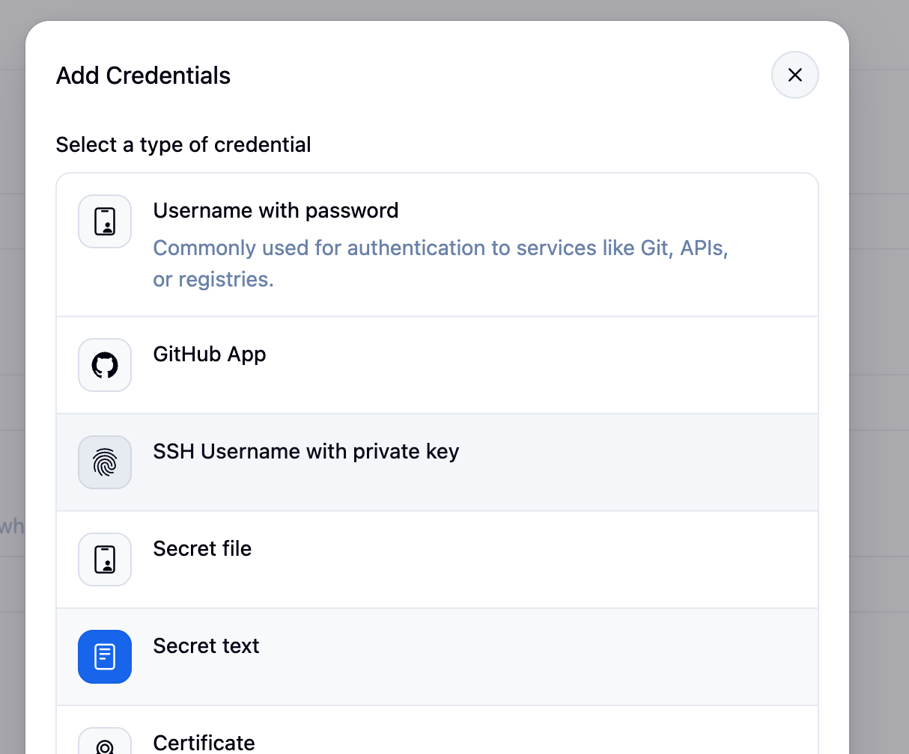

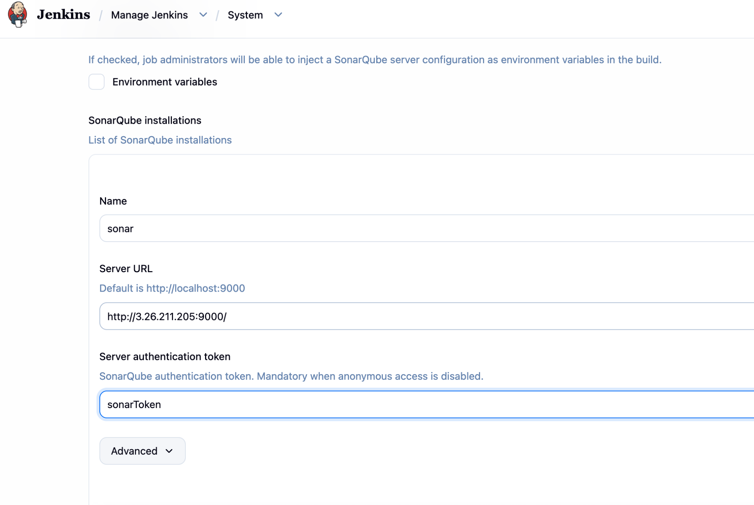

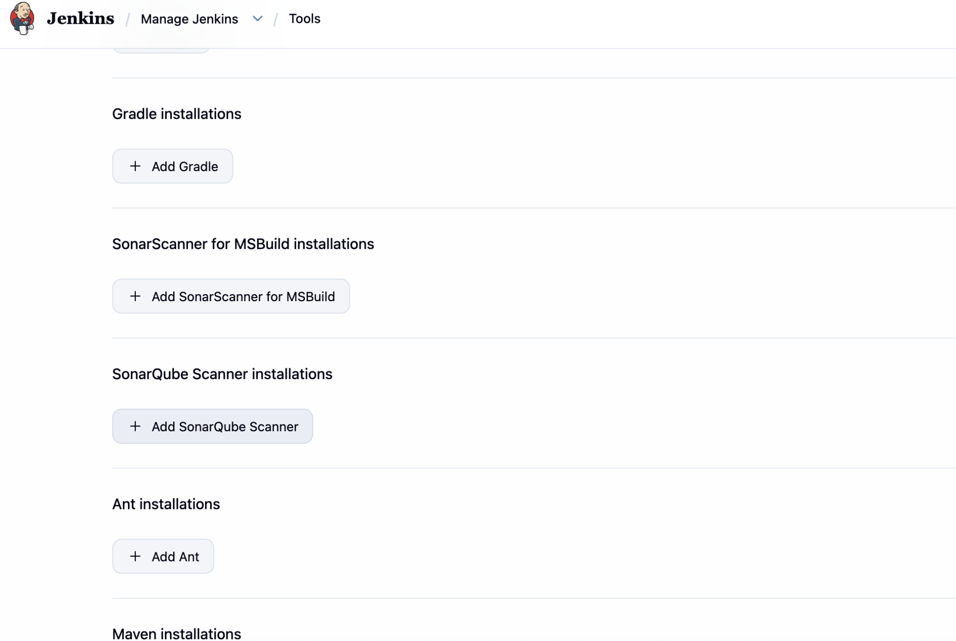

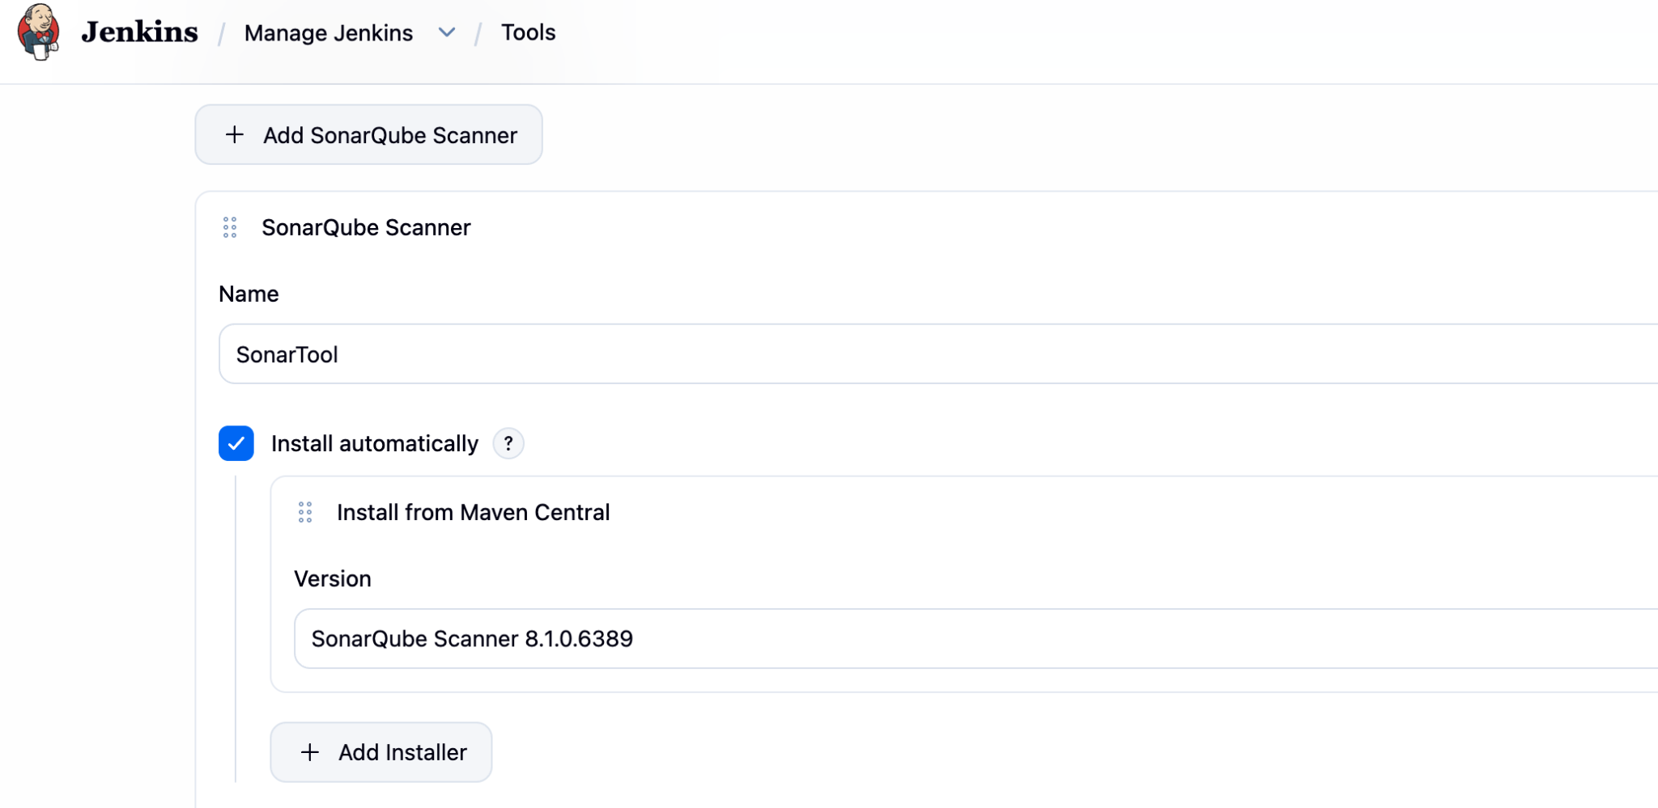

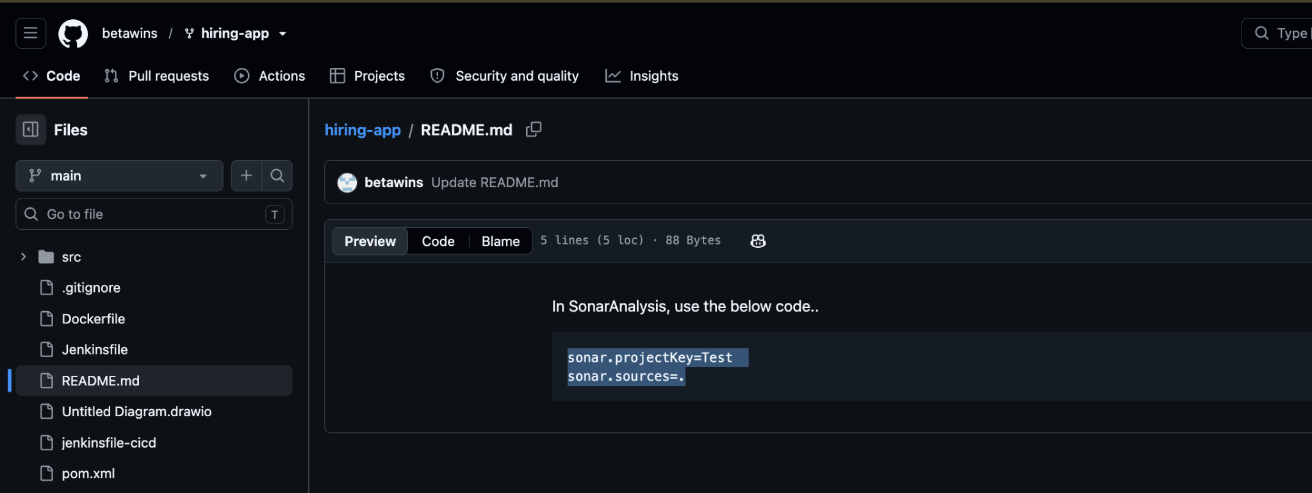

Add sonar.projectKeys=Test
sonar.sources=.
Add it in Jenkins after plugins (Sonarqube) → System → add in sonarqube
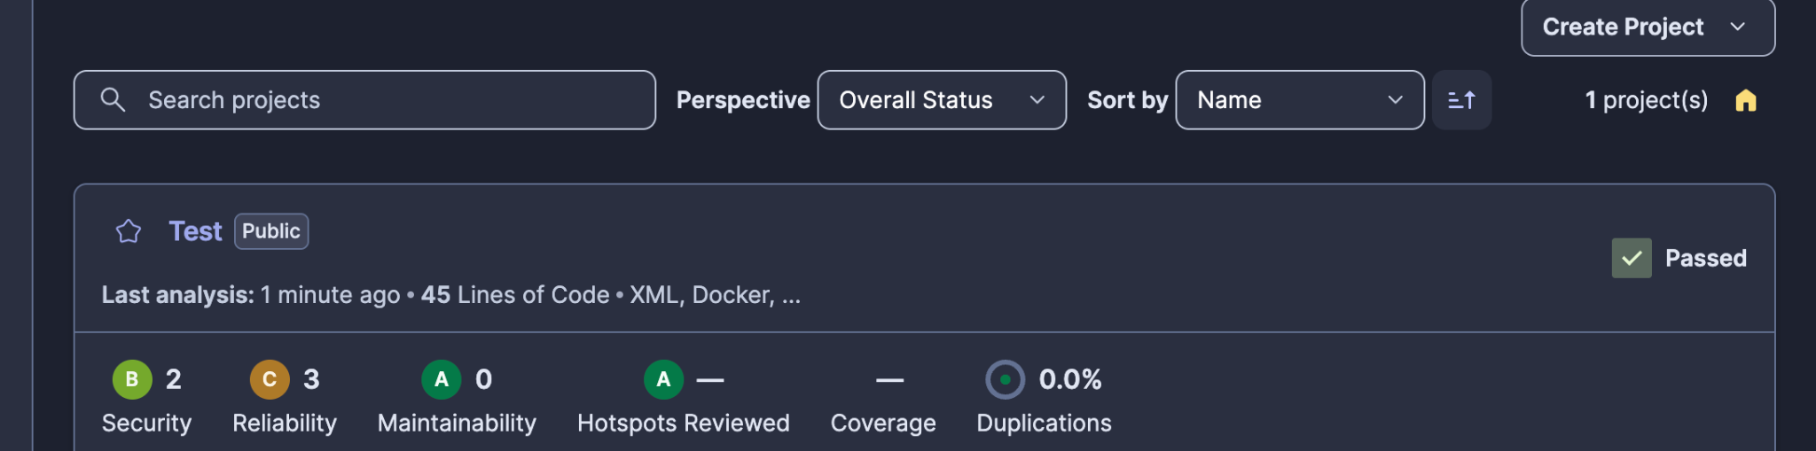

SetUp Slack Integration

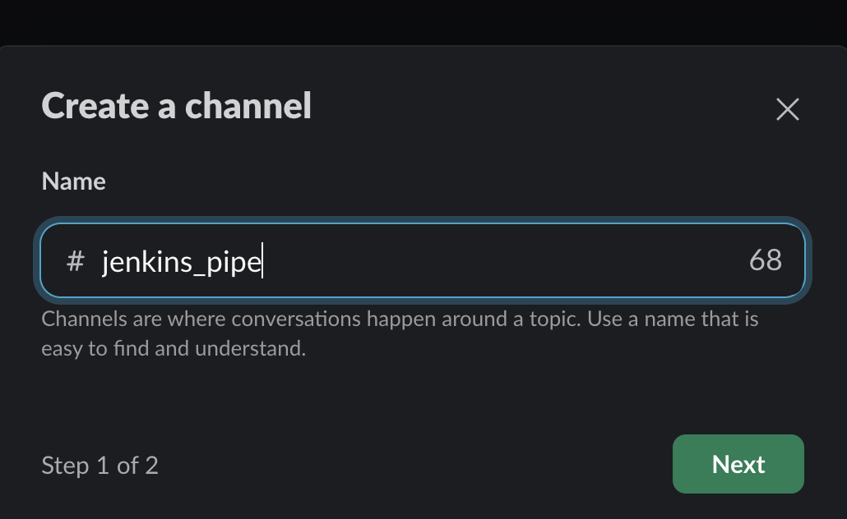

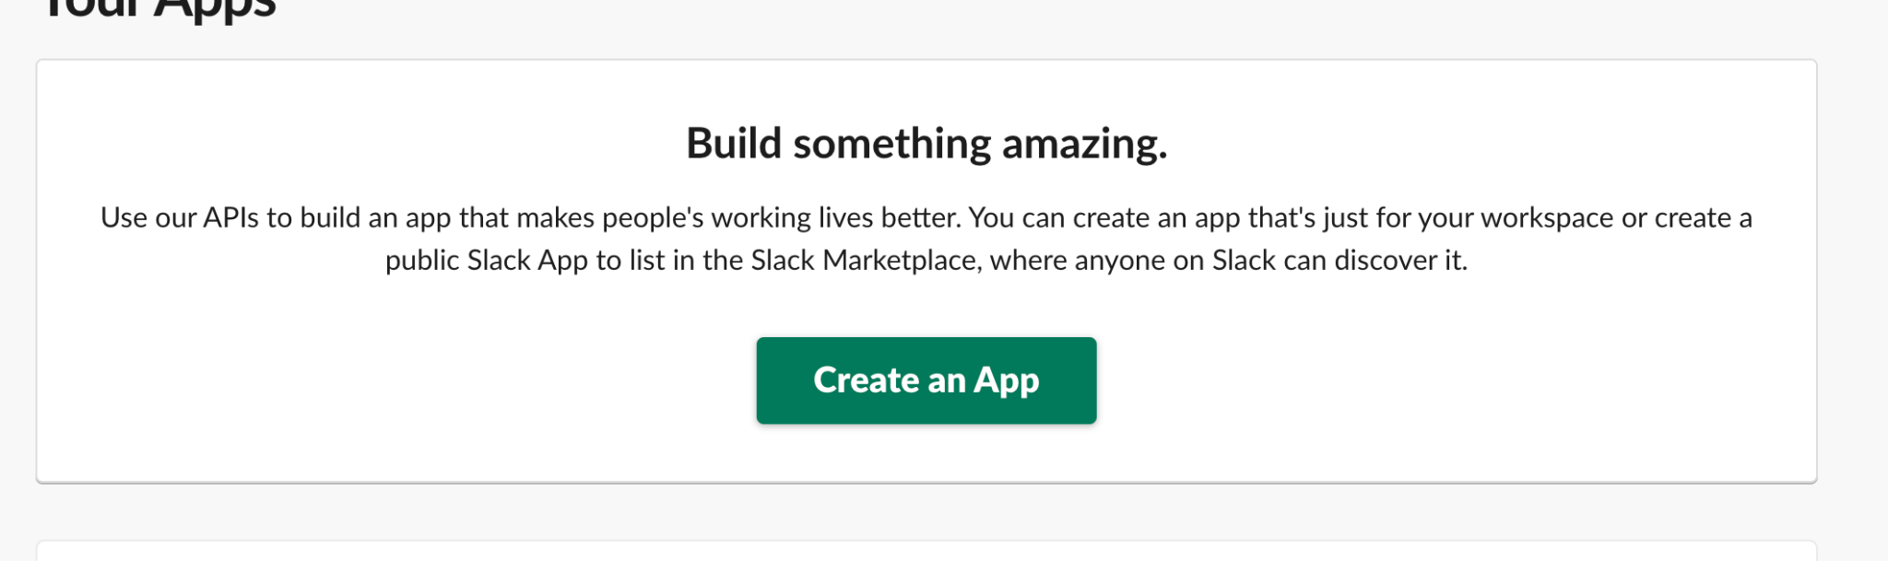

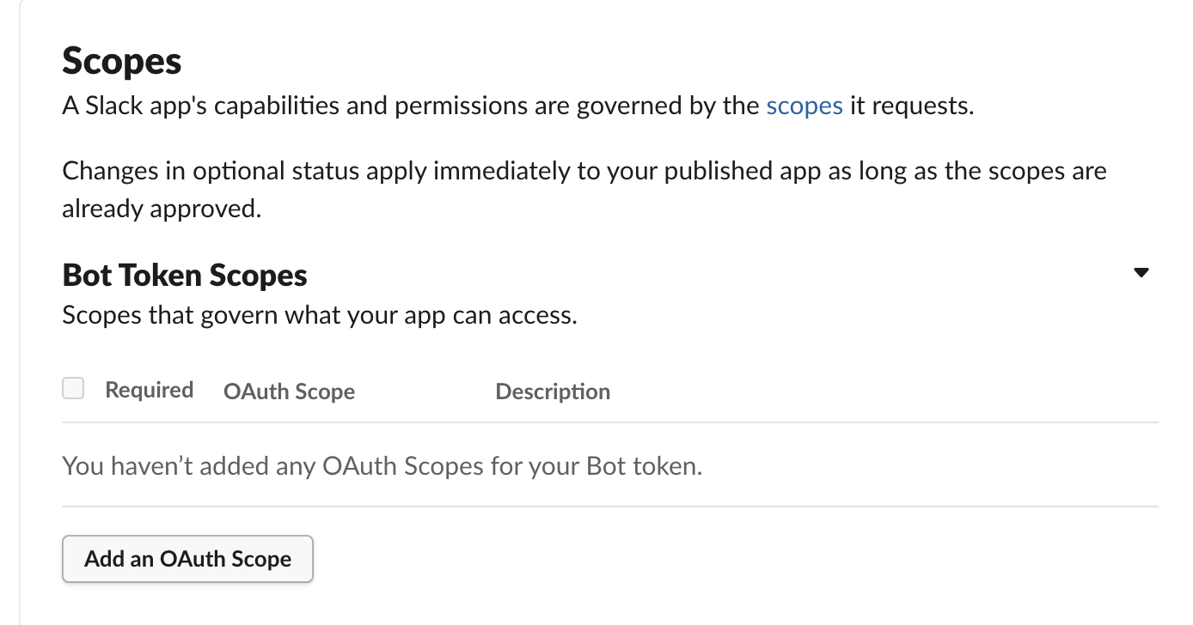

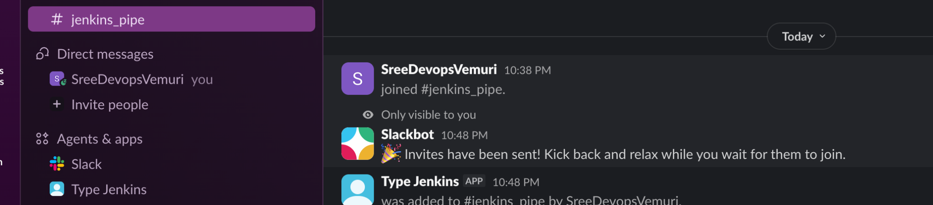

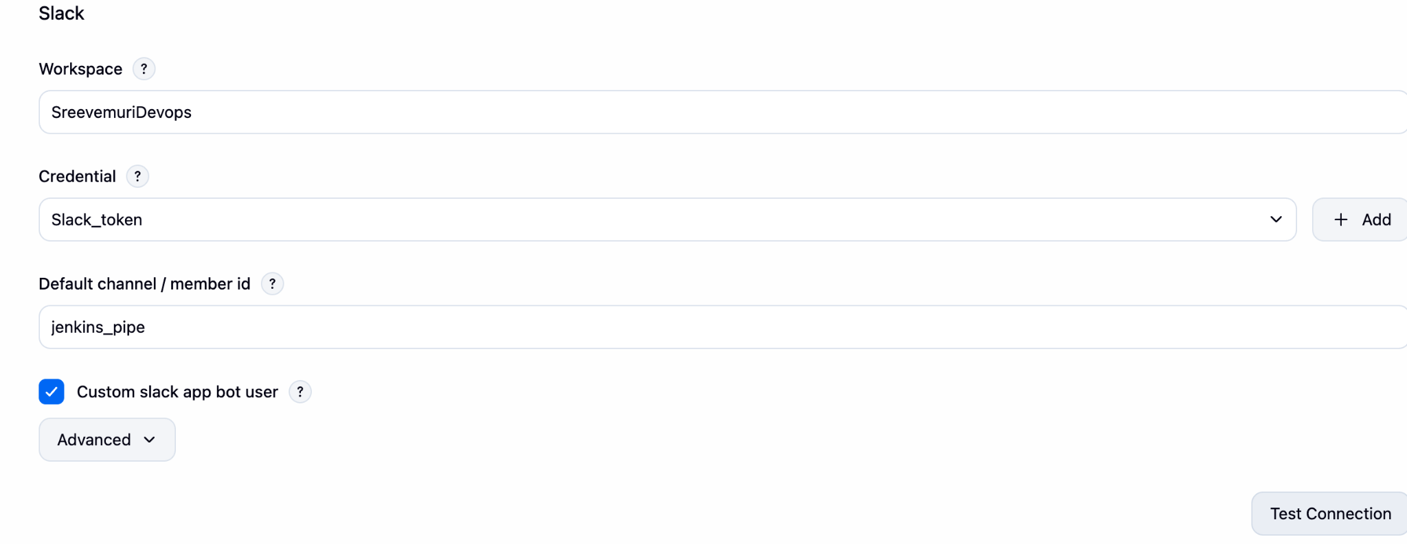

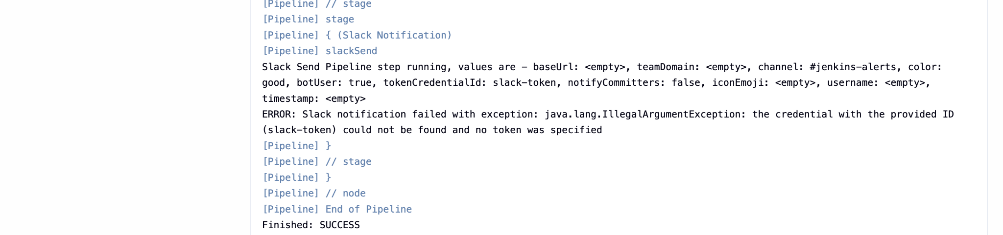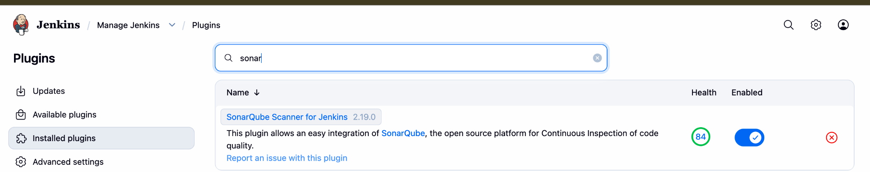

Method -2 With DOCKER
Install Docker with the command of
yum install docker-y
Systemctl start sonarqube
docker pull sonarqube
docker image sonarqube
